**MyHotkeys**

The main concept of this program is to make shortcuts (keyboard hotkeys) for all daily common functions, including making WIN key on workstations works as FN key on laptops.

After you run this tool, the following popup message will appear for **5 seconds**:

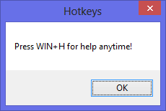

As you see the message, you can hold WIN key then press “H” to display the help message:

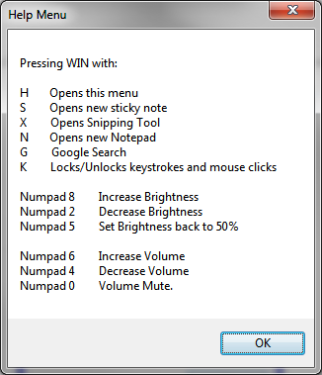

While this tool open, you can see the tray icon toggled in notification area. Three commands available: **Suspend** (to pause the program), **About**, and **Exit**.

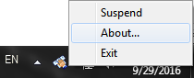

**Hold WIN key**  **with:**

**S:**

Opens **Sticky Note**, and if it is already exist open a new one.

**X:**

Opens **Snipping Tool**.

**N:**

Opens a new **Notepad**.

**G:**

Message box will appear asking you “what do you want to search in google.com?”

After you write your word(s), google.com will open in your default internet browser with your search result.

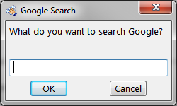

**K:**

Locks/Unlocks keystrokes and mouse clicks

**Volume and Brightness:**

Now, Increase\Decrease Brightness and Volume by using WIN key with the calculator side on our keyboards.

**Brightness:**

8 and 2 to Increase and reduce, 5 to restore to 50%

Moves by +\- 8 each click.

**Volume:**

4 volume down, 6 volume up, and 0 to mute.

Moves by +\- 2 each click.

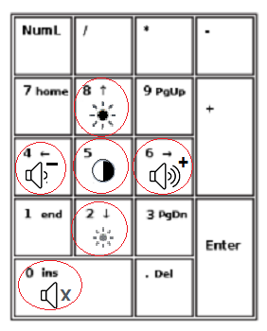

**Notes:**

* We can see the horizontal volume bar when we change the volume:

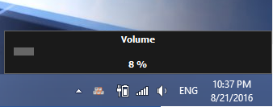

* This tool is small and light enough to add it into your **Startup** folder

